Agent Compensation Report Pseudocode:

- First, several variables are defined and set to a value.
  - @begin_date
    - date selected by end user on dashboard
      - ex: 2019-03-01
  - @end_date
    - date selected by end user on dashboard
      - ex: 2019-03-31
  - @date_span
    - takes the begin date and end date user selected and creates one text field that is a combination of those two dates
      - ex: 2019-03-01 - 2019-03-31
  - @current_year
    - takes the year of the begin date
      - ex: @begin_date = 2019-03-01, then @current_year = 2019
  - @current_year_plus_1
    - takes the year of the begin date and adds one year
      - ex: @begin_date – 2019-03-01, then @current_year_plus_1 = 2020.
  - @begin_date_for_member_months
    - set to be the first of the year for the @current_year
      - ex: @current_year = 2019, then @begin_date_for_member_months = 2019-01-01.
  - @end_date_for_member_months
    - set to be the first of the year for the @current_year_plus_1
      - ex: @current_year_plus_1 = 2020, then @end_date_for_member_months = 2020-01-01

- Next, a temporary table (#broker_compensation) is built using the broker_compensation table on DEV.MedicareEligibility.
  - the logic behind this table results in a table of all fields in the broker_compensation table coming back from the query, along with the member_id that is pulled in from the Consolidated_Medicare_IDs table via HICN.
    - the results are limited to showing only those records that are associated with the most recent file
      - file_date is taken from filename
        - ex: filename = P.RH2161.COMPRPT.D190204.T1318057.14232657, then file_date = 2019-02-04
      - the most recent file identification logic joins the broker_compensation table back onto itself using the first 9 digits of the HICN.
      - the H1977 contract is excluded
- Next, the main temporary table (#final) is built using the eligibility table from REPORT.UPHP_Prod_Replica.
  - pertinent fields included from eligibility
    - eligibility_ud
    - term date
  - Joined to #final are:
    - the “Member” supplemental info (si) table from REPORT.UPHP_Prod_Replica
      - joined on eligibility.member_id when si.form name = Member AND where si.field_43 (AGENT) is NOT null.
      - pertinent fields included in output: none
        - this join used only to limit the dataset to those members who have an agent.
    - the member table from REPORT.UPHP_Prod_Replica
      - joined to eligibility table on member_id
      - pertinent fields included in output: member first name and member last name
    - the termination_reason table from REPORT.UPHP_Prod_Replica
      - joined to eligibility on termination_reason_id
      - pertinent fields included in output: termination_reason_nm
    - the agent_info table from REPORT.Data
      - joined on these fields:
        - concatenated field: [Agent/Broker (A/B) Last Name] + comma/space + [Agent/Broker (A/B) First Name]
          - ex: […Last Name] = “ Smith” and […First Name] = “Bruce “, then this concatenation would return:
            - “Smith, Bruce”
              - logic also built in that removes leading and trailing spaces from names, if they exist.
        - and si.field_43
          - when si.field_43 begins with these two characters: “I-“ it removes them and returns the remaining characters, otherwise the si.Field_43 field is returned
            - ex: WEISSERT, WILLIAM
              - logic also removes leading and trailing spaces, if exists.
        - pertinent fields included in output: [Agent] and [Agency Name] from agent_info
    - the broker_compensation table from DEV.MedicareEligibility
      - joined to member table on member id and latest ReportGenerationDate from broker_compensation
      - pertinent fields included in output:
        - CorrectionIndicator
        - CycleYearAsOfReportGenerationDate
        - [Rapidly Disenrolled] field
          - this field populates with ‘Yes’ when the EnrollmentEffectiveStartDate from the broker_compensation table is less than three months before the members eligibility termination date. Otherwise, this field returns null.
        - [Initial or Renewal] field
          - when the CycleYearAsOfReportGenerationDate from broker compensation is less than or equal to one, then return ‘I’, else return ‘R’

- Finally we have two CROSS APPLY statements
  - the Member Months (mm) Cross Apply:
    - the calculation of member months has different levels of logic enclosed in a CASE Statement. (a case statement is a tool that allows the programmer to ask if a condition exists and then specify what is to be returned if the condition is true, false, or null.
      - example of a simple case statement:
        - CASE WHEN 1 = 1 THEN ‘TRUE’
WHEN 1 = 0 THEN ‘FALSE’
WHEN 1 not in (‘1’, ‘0’) THEN ‘ERROR’
END
    - logic behind Member Months Cross Apply:
      - first level: when eligibility term date is not null
        - if term date is not null, move on to second level logic
        - else skip down to third level logic
      - second level: (member has valid term date)
        - if a member was enrolled during the selected span (the ‘from date’ and ‘to date’ the user selected on dashboard) and not termed until after the end of the year:
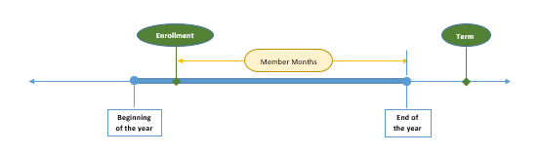
          - then calculate member months to be equal the number of months between the EnrollmentEffectiveStartDate (broker compensation table) and the end of the selected year.

        - else when a member has been enrolled for more than 12 months (enrolled before beginning of year and termed after the end of the year)
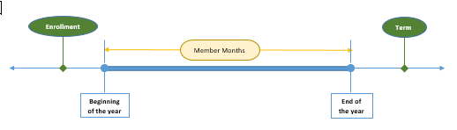
          - return the number 12 (total months of whole year)
        - else when a member’s EnrollmentEffectiveStartDate occurred in the year prior to their eligibility term date
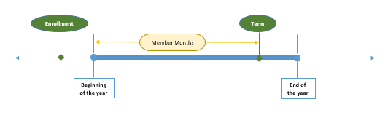
          - return the number of months between the beginning of the year and the member’s eligibility term date month that falls within the span selected.

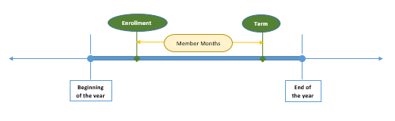
        - else return the number of months between the members EnrollmentEffectiveStartDate and the member’s eligibility term date as they fall within the selected span.

      - third level: (member does not have a term date, i.e. still active)
        - if a member’s EnrollmentEffectiveStartDate is greater than the beginning of the year
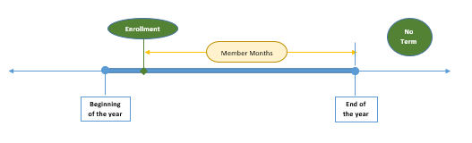
          - then return the number of months between their EnrollmentEffectiveStartdate and the end of the year based upon selected span
        - else, the member was enrolled at or before the beginning of the year
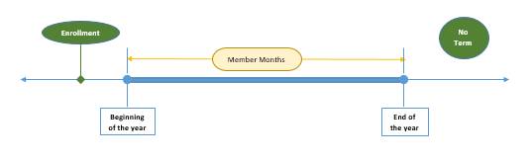
          - return the number 12 (total months of whole year)
  - The Commission Amount calculation uses the Monthly Commission Amount found for each Year and specific month span, this is done by finding the initial commission amount if the Cycle Years = 1 or the renewal commission amount if the Cycle Years does not equal 1 from the dbo.poa_PlanYear table in which the year on the table is the Year of the Begin Date and the Month of the Begin Date fits in one of the monthly spans on the table. This original commission amount is divided by twelve to the get the monthly rate. This monthly rate is then used in the following calculation to find the agent’s commission amount:
    - another case statement used to calculate the correct rate an Agent should receive based upon Cycle Year from broker compensation table, Current Year, and Member Months.
      - when CycleYear is less than or equal to 1 AND CurrentYear is < 2018:
        - apply this calculation:
          - member months multiplied by [ InitialCommissionAmt (from poa_PlanYear table) / 12 ]
            - where PlanYear Year = Current Year and Month of Begin_Date (selected as the start date when you ran the dashboard) is between MemberMonthStart and MemberMonthEnd (from poa_PlanYear table.)
      - when CycleYear is less than or equal to 1 and Current Year is greater than or equal to 2018:
        - apply this calculation:
          - [ InitialCommissionAmt (from poa_PlanYear table) / 12 ]
            - where PlanYear Year = Current Year and Month of Begin_Date (selected as the start date when you ran the dashboard) is between MemberMonthStart and MemberMonthEnd (from poa_PlanYear table.)
      - when CycleYear is greater than 1 and Current Year is greater than or equal to 2018:
        - apply this calculation:
          - [RenewalCommissionAmt (from poa_PlanYear table) / 12]
            - where PlanYear Year = Current Year and Month of Begin_Date (selected as the start date when you ran the dashboard) is between MemberMonthStart and MemberMonthEnd (from poa_PlanYear table.)
      - all else:
        - apply this calculation:
          - member months multiplied by [RenewalCommissionAmt (from poa_PlanYear table) / 12]
            - where PlanYear Year = Current Year and Month of Begin_Date (selected as the start date when you ran the dashboard) is between MemberMonthStart and MemberMonthEnd (from poa_PlanYear table.)

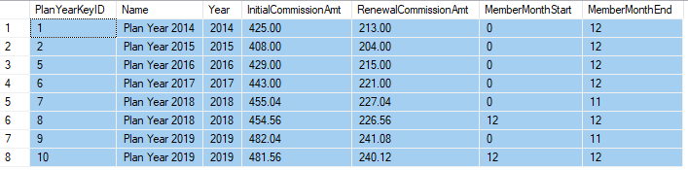
      - for reference—current state of the manually administered Applications.dbo.poa_PlanYear database:

- Finally, conditions are placed on the data pull from the #final table to ensure accuracy:
  - employer group from eligibility must be like “H2161…”
  - and group contract from eligibility NOT like CHOICELEP or MADVPREMIUM
  - and EnrollmentEffectiveStartDate from broker compensation must be less than the members term date (if no term date, substitute dummy date of 12/31/2099)
  - and termination reason (when non-null value) not equal to “PREMIUM CHANGE”
  - and Begin Date parameter selected by end-user on dashboard is between eligibility effective date and eligibility term date (if no term date, substitute dummy date of 12/31/2099)
  - and eligibility term date is greater than End Date parameter selected by end-user on dashboard –OR— eligibility term date between Begin Date and End Date. (if no term date, substitute dummy date of 12/31/2099)
  - and finally, limit output by user-selected agency
    - sorted by Agency Name, Agent Name, Member Last Name
- Report Output:
  - Policy Number
  - Beneficiary Last Name
  - Beneficiary First Name
  - Eff Date
  - Term Date
  - Correction Indicator
  - Cycle Year
  - Member Months
  - Commission Amount
  - Agent
  - Agency Name
  - Rapidly Disenrolled Flag
  - Termination Reason
  - Date Span selected when user ran report

